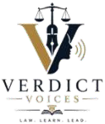

VERDICT VOICES LAW REVIEW

Copyright Transfer & PUBLICATION FORM

Manuscript Details

Title of Manuscript
Article Type (Research
Paper, blog etc.)
Word Count Approx.

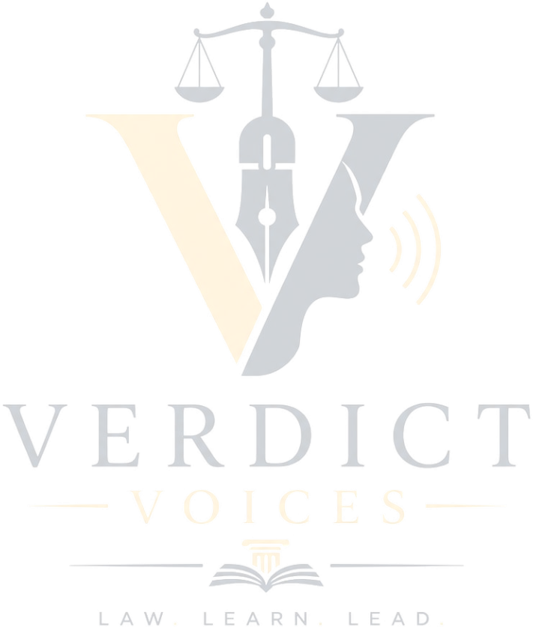
- AUTHOR DETAILS

S.  No | Full Name | Designation | Institutional  Affiliation | Email  Address | Contact  Number | Address
1.
2.

- COPYRIGHT AGREEMENT:
The undersigned author(s) hereby irrevocably assign, transfer, and convey to Verdict Voices all rights, title, and interest in and to the copyright of the above-referenced manuscript, including all renewals and extensions thereof, throughout the world and in all languages and media. By executing this Agreement, the author(s) confirm and warrant that:

I hereby declare and agree, on behalf of myself and my co-authors (if any), that:
- The Work is original and has not been published, submitted, or accepted for publication elsewhere.
- The article contains no such material that may be unlawful, infringe any proprietary or personal rights of others (including, without limitation, any copyrights or privacy rights).
- All co-authors have reviewed the final version and consented to its submission and to the terms of this Agreement.

- If any plagiarism is found in my camera-ready article after Publication, I am solely responsible, not Research Publish Journals or its Board members.
- Any third-party material reproduced within the Work has been duly credited, and all necessary permissions have been obtained.
- The Work complies with all applicable laws and does not contain defamatory, obscene, or unlawful content.
- In the event of any dispute, the final decision shall be made by Research Publish Journals.
Verdict Voices reserves the right to edit, format, and publish the Work in any medium, including print and digital. The corresponding author retains the right to self-archive a pre- print version of the Work, provided that proper attribution to Verdict Voices is given upon publication.

- AUTHOR RETAINED RIGHTS

Notwithstanding the above assignment, authors retain the non-exclusive right to:
- Reproduce the Work for personal, non-commercial, and educational purposes.
- Post the accepted manuscript on personal websites, SSRN, or institutional repositories, with
- a citation to the Verdict Voices publication.
- Present the Work at academic conferences and seminars. Include the Work in a thesis or dissertation.

- SIGNATURE AND CERTIFICATION

Authors’ Signatures: Author’s Name:

Date: Institution:
This form must be signed by the corresponding author. Digital signatures are accepted. This agreement is governed by the laws of India.
© Verdict Voices — All Rights Reserved

